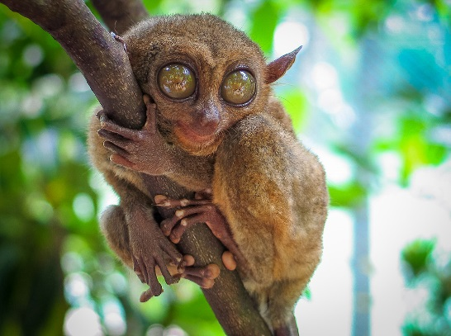
Jan 17th – 28th, 2020

Itinerary
Day 1 (Jan 17th, 2020)
Arrive to Cebu, Philippines.
Overnight: Cebu City
Day 2
Morning at leisure, Cebu City tour in the afternoon.
Overnight: Cebu City Meals: B
Day 3
Bohol tour. Visit the Chocolate hills, the man-made forest, and the Tarsier monkey sanctuary.
Overnight: Cebu City Meals: B, L
Day 4
Kawasan canyoneering adventure. Enjoy this beautiful canyon as we swim, slide and jump our way down.
Overnight: Cebu City Meals: B, L
Day 5
Fly to Puerto Princesa. Enjoy a Puerto Princesa city tour, before we transfer to Sabang.
Overnight: Sabang Meals: B
Day 6
Today we will visit one of the 7 wonders of nature, the Puerto Princesa Underground River. Transfer to El Nido.
Overnight: El Nido Meals: B, L
Day 7
El Nido island hopping adventure. Enjoy the views and the beautiful beaches of this intriguing country.
Overnight: El Nido Meals: B, L
Day 8
Transfer via fast ferry from El Nido to Coron. Coron city tour.
Overnight: Coron Meals: B, D

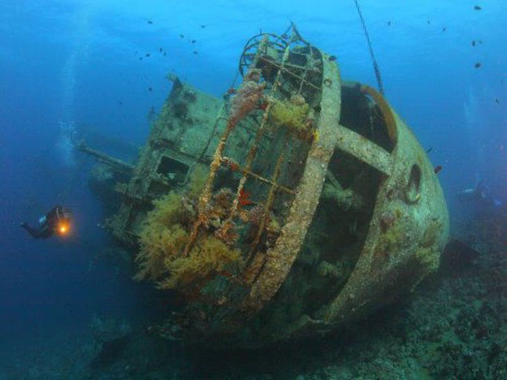

Day 9
Coron island hopping adventure, includes snorkeling on amazing reefs and WW II ship wrecks.
Overnight: Coron Meals: B, L
Day 10
Today, we will island hop between some of the world’s most unique landscapes and beautiful beaches.
Overnight: Coron Meals: B, L
Day 11
Flight to Manila. Enjoy a tour of this interesting city.
Overnight: Manila Meals: B
Day 12 (Jan 28th)
Depart for home. Meals: B
Highlights & Cost
Highlights:
- Puerto Princesa Underground River
- Kawasan Canyoneering adventure
- Bohol – Chocolate hills and Tarsier Monkeys
- Island hopping (beaches & ship wrecks)
Cost: $1999 per person, double occupancy.
Price is for the land tour, intra country flights & travel insurance. The price does not include international airfare.
Contact:
Troy@ldsgrouptravel.org
WWW.ldsgrouptravel.com
1-800-991-5123
LDS Group Travel
3949 E. Easy Jet Drive
Meridian, ID 8364

